**CSCE 5430 SECTION 009 – SOFTWARE ENGINEERING**

**DELIVERABLE -2**

**PROJECT NAME : ANDROID WOMEN SAFETY APP**

**TEAM NAME : SOFTWAREENGINEERING_PROJECT**

**TEAM MEMBERS:**

Krishna Sai Ujwal Kambhpati

Vineesha Sangepu

Sharan kumar Pallapu

Praveen Reddy

Jayakanth Madineni

Vineela Pamarthi

Sai Tai Prathyusha

**System Structure**

Below is the structure of the app that we are planning to develop:-

* User logs into the app using registered Username and password using login button
* If a new user opens the app, user can Register themselves using signup button
* We have implemented authentication for the security reasons where the user receives a one time password (OTP) when they try to login to the already existing account.
* When the user clicks on sign up it displays the information the user must enter to create a new account in the app
* After the user clicks on the login, the details in user profile are editable if required.
* There is an error message that pops up when the user enters wrong user Id or password.

“ Invalid User Id or password ”

* The details that are displayed and can be edited in the Profile -> Account module are

Account:

* Full Name
* User Id
* Change Password
* User Email Address
* Emergency Contact details
* User is enabled to add a new emergency contact
* Delete the existing contact.

Three options available for the user on the menu are:

1. Emergency Alarm:

This Alarm is used when there is an urgent message that has to be sent to the predetermined emergency contact. This feature allows the user to alert the emergency contact in less duration of time.

2. Cautious:

The following feature allows the user to alert the emergency contact and the application shows busy feature for the user.

3. Status Transmission:

This feature is used to transmit the status of the user. It provides the user to send the current location of the user to the emergency contact which enables the emergency contact to track the user’s location.

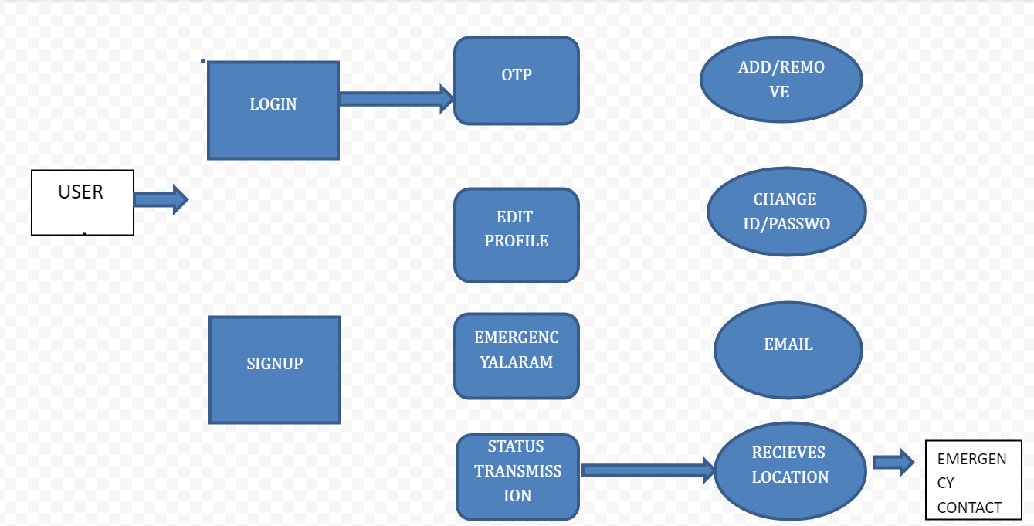

Permissions required for the application :

There are few permissions that are required in the background for the application to run successfully on the user’s mobile:

* Location Access:

User must allow access to the location using the google maps. The pop up displays when the user installs the application in the mobile and the user must click on Allow.

* Microphone Access:

User must allow access to the microphone. The pop up displays when the user installs the application in the mobile and the user must click on Allow.

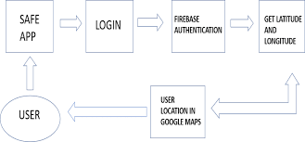

**Functional requirements:**

1. Registration in the system must be available to the user.
2. User profiles, including things like phone numbers for emergency contacts, should be editable by the user.
3. There should be three options available to the user at all times: emergency alarm, cautious, and status transmission.
4. During a panic alarm, an urgent message must be delivered to a predetermined emergency contact.
5. A warning to keep busy will be sent out in case of emergency.
6. Whenever an emergency occurs, the user's location should be transmitted to a predetermined contact using the "send status" option.
7. The system needs a panic alarm function where the user may send a message by shaking their phone.
8. By choosing the transmit status and cautious option, the system will be able to send the message.

**Non-functional requirements:**

1. Allows numerous users to connect at once.
2. "View only" and "full control" modes of operation.
3. Windowed, full-screen, and scaled display options.
4. Operates in the background as a service on Windows NT computers.
5. Supports DHCP and can traverse firewalls.
6. Allows for expansive colour palettes and pixel densities.

**Interfaces:**

1. Android studio
2. Java JDK
3. Windows i5 500 GB HDD

* Android users may utilizes this program to assist them get out of jams. Users may find a HELP button anywhere inside the application. A message and up to three phone numbers may be left.
* Whenever the user wants assistance, all they have to do is launch the app and tap the "HELP" button. He may send a text message to any of his contacts from inside the programme.

**Phases of Application:**

We'll break down the three most prevalent ways of completing the overall assessment for you below. The application release process is broken down into three stages throughout the evaluation phase.

* Phase 1:

The first order of business is to enter the contact information into the brand new app. Family members, relatives, personal acquaintances, and even the head of police in our town might all be potential links. The user will be prompted to provide the a forementioned information during the app’s first download on a smart phone. This data will be stored eternally in the computer system.

* Phase 2:

Getting in touch with emergency contacts and sending them your GPS coordinates or a link to your position via a third-party stock map tool like Google Maps, Apple Maps, etc. is the second most crucial thing to do if someone is in danger or needs to be rescued. Only pressing the "rescue" button will trigger this response. For this procedure to operate, the device must be linked to the proper mobile network and have its location service activated (GPS).

* Phase 3:

Sending regular messages to your registered contacts through the location's URL is the third essential action. We've settled on a 5-minute interval, at the conclusion of which an SMS will be sent to the authorised contacts.

As a result, the suggested system's main goal is to monitor the individual's precise position in real time so that they may be rescued.

The basic processes of project planning are:

Scope planning – specifying the in-scope requirements for the project to facilitate creating the work breakdown structure.

Preparation of the work breakdown structure – spelling out the breakdown of the project into tasks and sub-tasks.

**Team Roles:**

* Krishna Sai Ujwal Kambhpati (Group Leader): Design of the user interface and user experiences
* Vineesha Sangepu: Functional and Non functional requirements
* Praveen Reddy Talupu: System structure with sub systems
* Vineela Pamarthi: Designing of documentation , github and meeting minutes
* Jayakanth Madineni : System Architecture and planning
* Sharan Kumar Pallapu: Server connection and documentation
* Sai Tai Prathyusha Garikapati: Connecting teams and documentation.

**Member Contribution Table:**

|  |  |  |  |
| --- | --- | --- | --- |
| Member Name | Contribution Description | Overall Contribution | Note |
| Krishna Sai Ujwal Kambhpati | Design of the user interface and user experiences. | 12% |  |
| Vineesha Sangepu | Worked on the Functional requirements of the project and the subsystems that are present in the project. | 14% |  |
| Praveen Reddy Talupu | Worked about the system structure and the design of the application | 12% |  |
| Vineela Pamarthi | production of content and documentation design. Additionally, I created the github readme file and the meeting minutes file. | 12% |  |
| Jayakanth Madineni | Worked on the architecture and diagram representations. Organised zoom meetings for the team to discuss. | 12% |  |
| Sharan kumar pallapu | Server connection and documentation. I have also shared ideas of functionality as emergency alarm, status transmission. | 14% |  |
| Sai Tai Prathyusha Garikapati | Connecting teams and frontend designs.  Also made final changes in document | 12% |  |